NIT2102 Cyber Security Essentials

Intelligent Hospital SOC and Medical IoT Security

AI/ML-Assisted Threat Detection, Correlation and Automated Response
Student Name: VANSHIL RADADIYA
Student ID: [s8200539]
Submission Date: [17/08/2026]

1. Executive Summary

Healthcare environments increasingly depend on connected medical devices and legacy information systems, creating security risks that can directly affect the confidentiality, integrity and availability of clinical information. This project designed and implemented a simulated hospital cybersecurity solution focused on protecting a medical IoT patient monitor and a legacy hospital server from reconnaissance, unauthorized access and telemetry manipulation.
The implemented architecture consists of a simulated ICU Patient Monitor (ICU-MON-01), a Legacy Hospital Server (LEGACY-SRV-01) represented by Metasploitable2, an authorized Kali Linux Security Testing Workstation (SEC-WS-01), and a macOS-based Hospital Security Operations Centre (SOC-01). A custom Python SIEM was developed to centralize security events, identify hospital assets, calculate context-aware risk, correlate related events and maintain auditable alert and incident records.
The solution incorporates a lightweight Random Forest AI/ML classifier to classify detected security events and provide confidence scores. Medical-aware dynamic risk scoring evaluates the security significance of telemetry modifications, while correlation identifies patterns such as repeated authentication failures, reconnaissance activity and successful authentication followed by telemetry modification. A passive network-monitoring capability was also integrated to observe reconnaissance directed at the legacy hospital server.
Automated defensive response logic generates actions according to detected risk, including enhanced monitoring, access-restriction recommendations and immediate isolation recommendations for critical medical telemetry integrity events. The completed system therefore demonstrates a layered hospital security architecture combining application monitoring, network monitoring, SIEM analysis, AI/ML-assisted classification, correlation and automated incident-response recommendations.
The design supports principles associated with defence in depth, Zero Trust and continuous monitoring, while maintaining human oversight for potentially disruptive containment actions in a safety-critical healthcare environment.

2. Threat Analysis & Research

2.1 Problem Statement
Modern healthcare environments increasingly rely on interconnected medical devices, clinical workstations and legacy information systems. Medical Internet of Things (IoT) devices such as patient monitors continuously process clinically relevant information and may communicate with other hospital systems. This connectivity improves healthcare operations but also expands the cyberattack surface.
This project focuses on two major risks within a simulated hospital environment: medical IoT compromise and exposure of legacy hospital systems. The simulated ICU patient monitor represents a critical medical IoT asset, while Metasploitable2 represents a legacy hospital server containing outdated and exposed network services. An attacker who obtains network access may perform reconnaissance to identify vulnerable services, attempt unauthorized access, compromise credentials or manipulate medical telemetry.
Telemetry integrity is particularly important because a cyberattack does not necessarily need to make a medical device unavailable to cause harm. Unauthorized modification of values such as heart rate, oxygen saturation (SpO₂) or temperature could undermine the reliability of information presented to healthcare staff. Therefore, the project focuses not only on preventing unauthorized access but also on detecting suspicious behaviour after successful authentication.

2.2 Threat Impact on Healthcare
A successful cyberattack against a healthcare environment can affect all three elements of the CIA security model:
- Confidentiality: unauthorized access may expose patient or operational information.
- Integrity: an attacker may manipulate medical telemetry, configuration data or other clinical information.
- Availability: compromised devices or servers may become unavailable to healthcare personnel.
The integrity risk is central to this project. For example, an attacker using a compromised but technically valid API credential could successfully authenticate to the simulated ICU monitor and modify telemetry. A security system based only on authentication might regard the request as legitimate. The implemented solution therefore monitors what occurs after authentication, correlating successful authentication with subsequent telemetry modification.
Legacy systems introduce another significant risk. Hospitals may retain older platforms because of compatibility, operational or financial constraints. Such systems can expose unnecessary or outdated services. Reconnaissance can therefore provide an attacker with information about open ports and available services before further intrusion attempts.

2.3 Real-World Relevance
Healthcare has repeatedly been affected by ransomware, data breaches and disruption of clinical technology. These incidents demonstrate that cyberattacks can have consequences beyond conventional information loss because healthcare organisations depend on technology for time-sensitive operations.
The simulated environment reproduces several behaviours relevant to these threats rather than attempting to reproduce a real destructive attack. The authorized Kali Linux workstation is used to perform controlled reconnaissance and access tests. The legacy hospital server provides an intentionally vulnerable system for observing network reconnaissance, while the ICU monitor allows authentication and telemetry-integrity scenarios to be tested safely.
The project therefore models an attack progression such as:
Reconnaissance
↓
Asset / Service Discovery
↓
Access Attempt
↓
Credential Use
↓
Telemetry Modification
↓
Security Detection and Correlation
This provides a realistic basis for evaluating whether multiple security events can be detected and connected as part of a larger incident.

2.4 Current Security Gaps
Several security gaps motivated the proposed solution.
Limited visibility: Individual applications may generate logs, but isolated logs do not provide a complete view of activity across hospital assets.
Legacy-system exposure: Older systems can expose multiple network services and may lack modern endpoint-monitoring capabilities.
Authentication is insufficient: A valid credential does not guarantee that the user or activity is trustworthy. Compromised credentials can allow malicious actions to appear authenticated.
Static severity ratings: Traditional rules may assign the same severity to every event of a particular type. In a medical environment, however, the potential consequence of changing heart rate from 76 to 80 BPM is different from changing it from 76 to 180 BPM. The project therefore implements medical-context-aware dynamic risk scoring.
Isolated alerts: Individual authentication failures, reconnaissance events and telemetry changes can appear unrelated without correlation.
Slow manual response: Detecting an alert without providing a response workflow increases the time required for analysts to decide what action should be taken.
The developed solution addresses these gaps through centralized event collection, hospital asset awareness, passive network monitoring, dynamic risk calculation, AI/ML-assisted classification, event correlation and automated defensive-response recommendations.

2.5 Threat Modelling and MITRE ATT&CK
The project uses the MITRE ATT&CK framework to describe attacker behaviour rather than viewing each event as an isolated technical alert. The tested scenario can be associated with several ATT&CK concepts, including reconnaissance/discovery activity, credential-related access and modification of information.
For example, scanning the legacy hospital server represents reconnaissance and service discovery behaviour. Repeated authentication failures may indicate attempts to obtain or misuse access. Successful authentication followed by unauthorized telemetry manipulation demonstrates why authenticated activity must continue to be monitored. Modification of patient telemetry represents an integrity attack against information processed by a critical hospital asset.
This ATT&CK-oriented approach improves the project beyond simple signature detection because the SIEM correlates sequences of behaviour. For example:
authentication_success
+
telemetry_modified
↓
Possible Compromised
Medical Device Credential
Similarly, repeated reconnaissance events within a defined time window can be elevated from individual alerts into a correlated reconnaissance incident.

2.6 Compliance and Security Framework Considerations
The solution was designed with principles from established cybersecurity and privacy frameworks in mind. NIST cybersecurity principles support asset identification, continuous monitoring, detection, response and recovery planning. ISO/IEC 27001 similarly emphasizes systematic information-security risk management, access control, monitoring and incident management.
Healthcare information can also contain personal and sensitive information. Consequently, privacy principles such as access limitation, accountability and auditability are important. The custom SIEM maintains persistent alert, incident and response records, supporting investigation and audit requirements.
The project also applies Zero Trust principles by avoiding the assumption that successful authentication automatically establishes trust. Authenticated activity continues to be monitored and evaluated according to asset criticality, event behaviour and medical context.
These threat and compliance considerations informed the layered security solution described in the next section.

3. Security Solution Design

3.1 Proposed Solution
A layered hospital cybersecurity solution was designed to detect network reconnaissance, unauthorized medical IoT access and patient-telemetry manipulation. The solution combines application monitoring, passive network monitoring, a custom SIEM, medical-aware risk scoring, AI/ML classification, event correlation and automated defensive response.
Four assets form the simulated hospital environment:
Asset | Role | Criticality
SOC-01 | Mac-based Hospital SOC and SIEM | Critical
ICU-MON-01 | Simulated ICU patient monitor | Critical
LEGACY-SRV-01 | Metasploitable2 legacy hospital server | High
SEC-WS-01 | Kali security-testing workstation | Medium

The asset registry enables the SIEM to associate security events with the identity, role and criticality of hospital systems.

3.2 Hospital Security Architecture
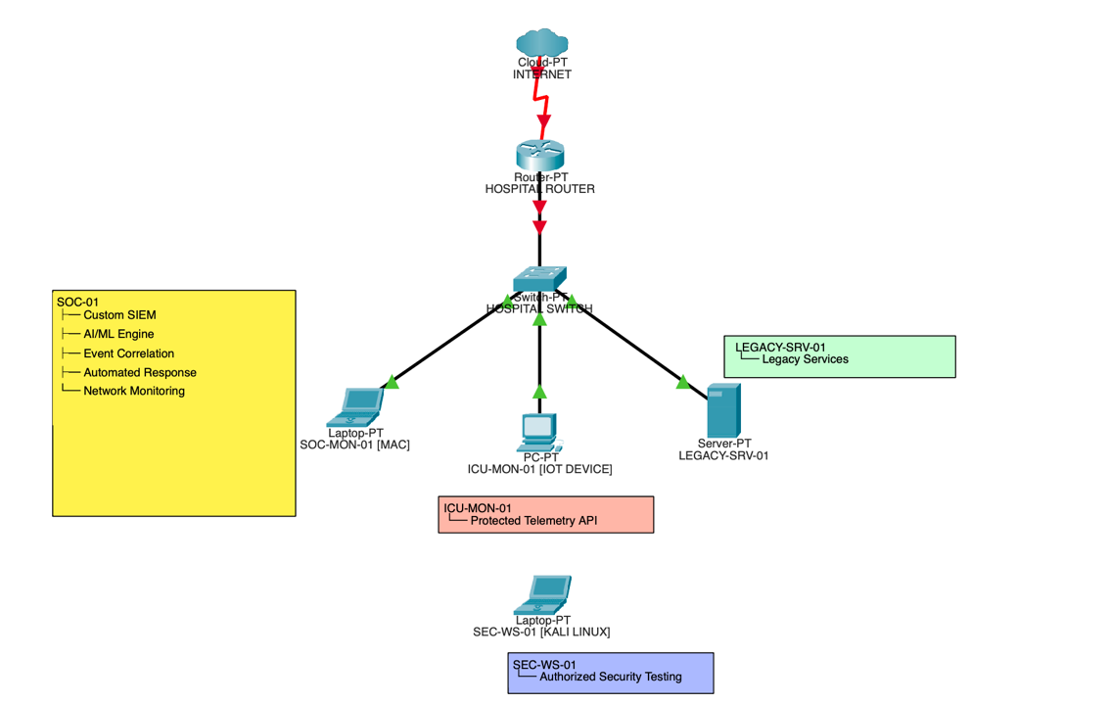
Figure 1. Logical topology of the simulated hospital cybersecurity environment.
The Packet Tracer topology represents the logical architecture of the project. The operational environment uses a macOS host for SOC-01 and ICU-MON-01, Kali Linux for authorized security testing, and Metasploitable2 as LEGACY-SRV-01.
The SOC receives application security events from the ICU monitor and passively monitors network traffic directed toward the legacy server. Both sources feed the custom SIEM for centralized analysis.

3.3 Layered Security Controls
The solution implements defence in depth through several integrated controls:
- Medical IoT protection: API authentication protects telemetry modification and records failed and successful authentication activity.
- Passive network monitoring: Multi-port connection activity against the legacy hospital server is detected as potential reconnaissance.
- SIEM and asset awareness: Events are centrally analysed and enriched with hospital asset criticality.
- Dynamic risk scoring: Telemetry changes are scored according to their magnitude and security context.
- AI/ML analysis: A Random Forest classifier provides security classifications and confidence scores.
- Event correlation: Related events, such as successful authentication followed by telemetry modification, are combined into higher-level incidents.
- Automated response: The system generates actions including ENHANCED_MONITORING, ACCESS_RESTRICTION_RECOMMENDED and ISOLATION_RECOMMENDED.
This approach also supports a Zero Trust principle, as successful authentication does not prevent subsequent activity from being monitored and analysed.

3.4 Security Workflow
Security Event → SIEM → Risk + AI/ML → Correlation → Response
Figure 2. Security-event analysis and automated-response workflow.
Events from the medical IoT application and network-monitoring component are processed by the SIEM. Risk scoring and AI/ML classification provide additional context before related events are correlated and an appropriate defensive response is generated.

3.5 Technologies
The solution uses Python and Flask for the simulated medical IoT system and security components, scikit-learn Random Forest for AI/ML classification, and tcpdump for passive network visibility. Kali Linux/Nmap provide controlled security testing, while Metasploitable2 represents the legacy hospital server. Cisco Packet Tracer is used only to illustrate the logical network topology.

4. Implementation & Testing
The solution was implemented using a macOS-based Hospital SOC, a simulated medical IoT patient monitor, Kali Linux for authorized security testing and Metasploitable2 as the legacy hospital server. The custom Python SIEM integrates real-time detection, asset awareness, AI/ML classification, event correlation and automated defensive response.

4.1 System Implementation
The simulated ICU-MON-01 patient monitor was developed using Python and Flask and generates heart rate, SpO₂ and temperature telemetry. Its protected API records successful and failed authentication attempts and telemetry modifications.
The custom SIEM processes these events in real time and also passively monitors network traffic directed toward LEGACY-SRV-01. A Random Forest classifier provides AI/ML-assisted classification, while medical telemetry changes receive dynamic risk scores according to the magnitude of the modification.
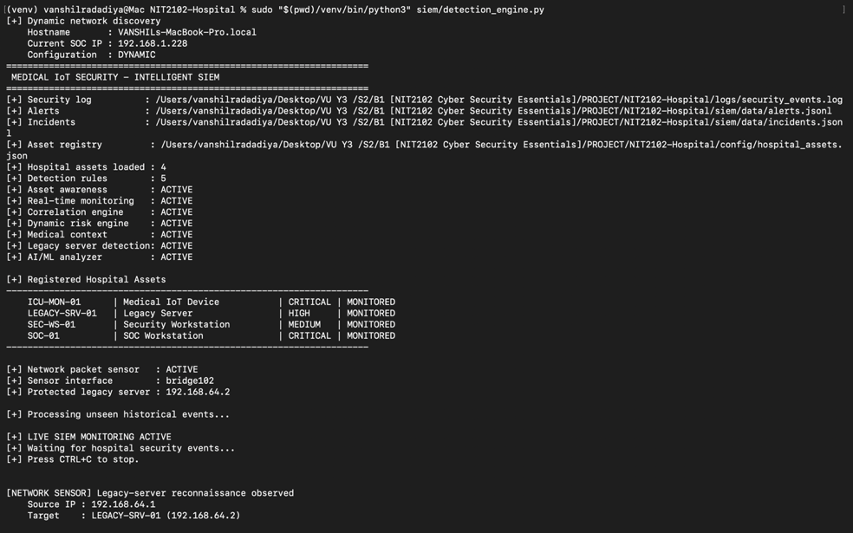
Figure 3. Custom Hospital SIEM implementation.

4.2 Legacy Server Reconnaissance Test
Kali Linux was used to perform an authorized Nmap scan against the Metasploitable2 legacy hospital server. The integrated network sensor detected rapid connections across multiple TCP ports and generated a network_reconnaissance alert.
The event was processed by the SIEM and AI/ML engine, and the automated-response system generated:
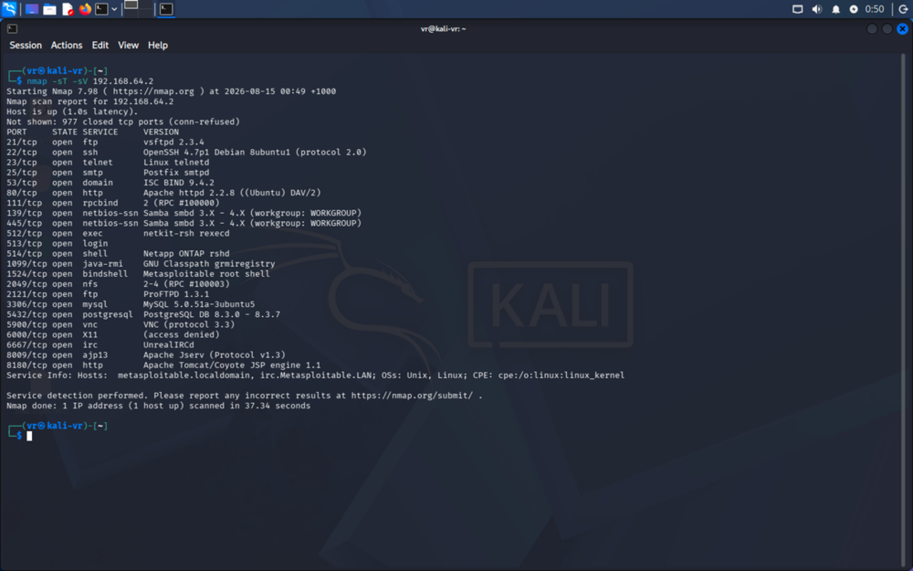
ENHANCED_MONITORING
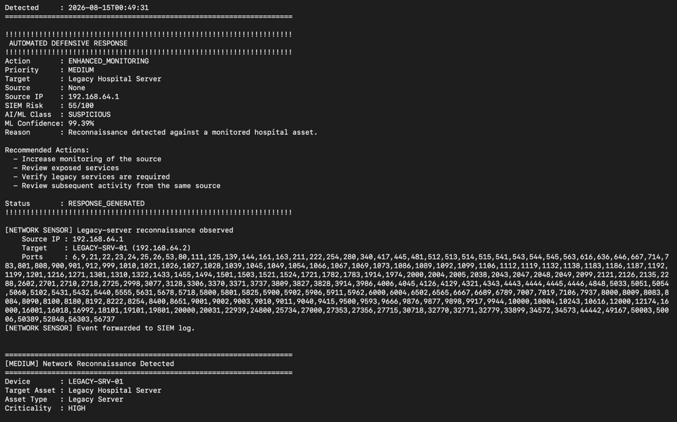
Figure 4. Detection of reconnaissance against LEGACY-SRV-01.

4.3 Unauthorized Medical IoT Test
An invalid API credential was used in an attempt to modify ICU patient telemetry. The request was rejected and generated authentication_failure and unauthorized_telemetry_change_attempt events.
The SIEM classified the activity as high risk and generated:
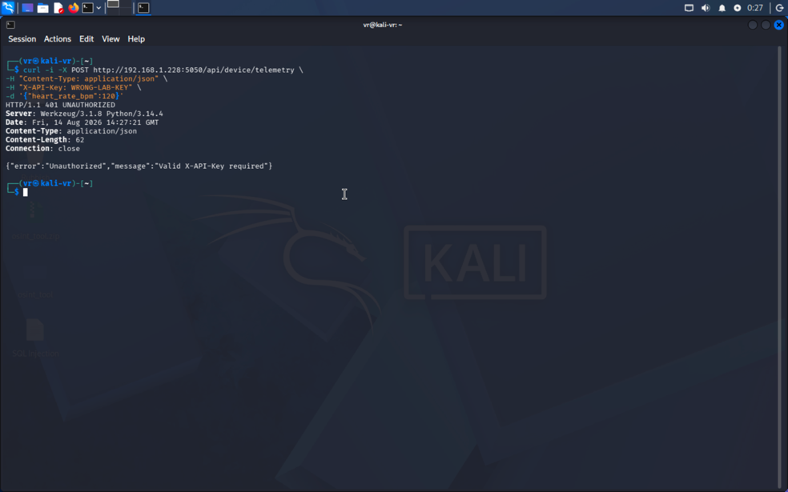
ACCESS_RESTRICTION_RECOMMENDED
This demonstrated that unauthorized telemetry modification could be prevented while simultaneously producing an auditable security alert.
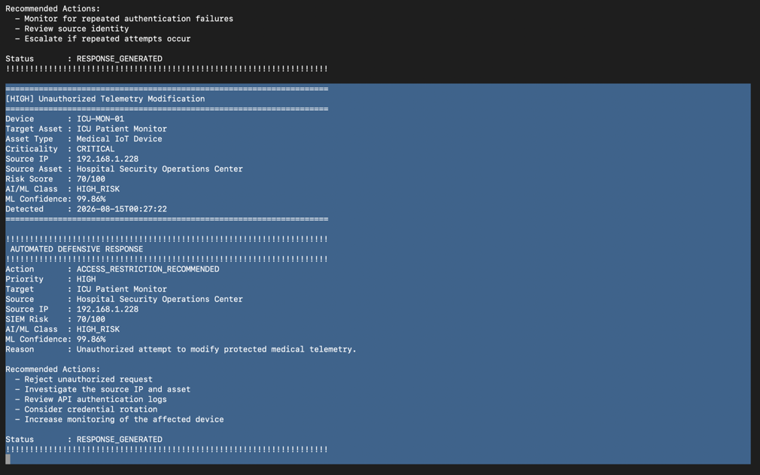
Figure 5. Detection of unauthorized medical IoT access.

4.4 Authenticated Telemetry Manipulation Test
A valid credential was then used to modify simulated patient telemetry. The system recorded authentication_success followed by telemetry_modified.
Medical-aware risk scoring evaluated the magnitude of the telemetry change, while AI/ML provided additional classification. Event correlation identified the sequence as:
Possible Compromised Medical Device Credential
For the critical event, the automated-response engine generated:
ISOLATION_RECOMMENDED — Priority: IMMEDIATE
This demonstrated that authenticated activity remains monitored rather than being automatically considered trustworthy.
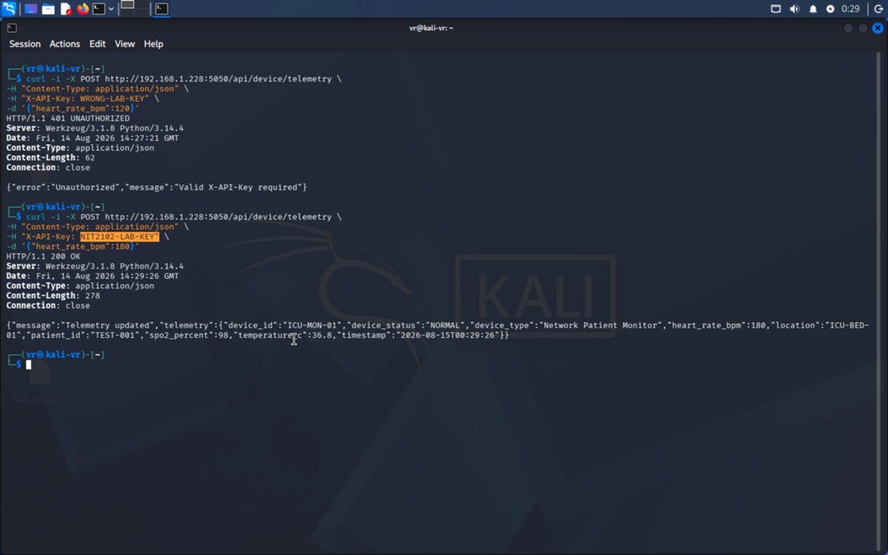
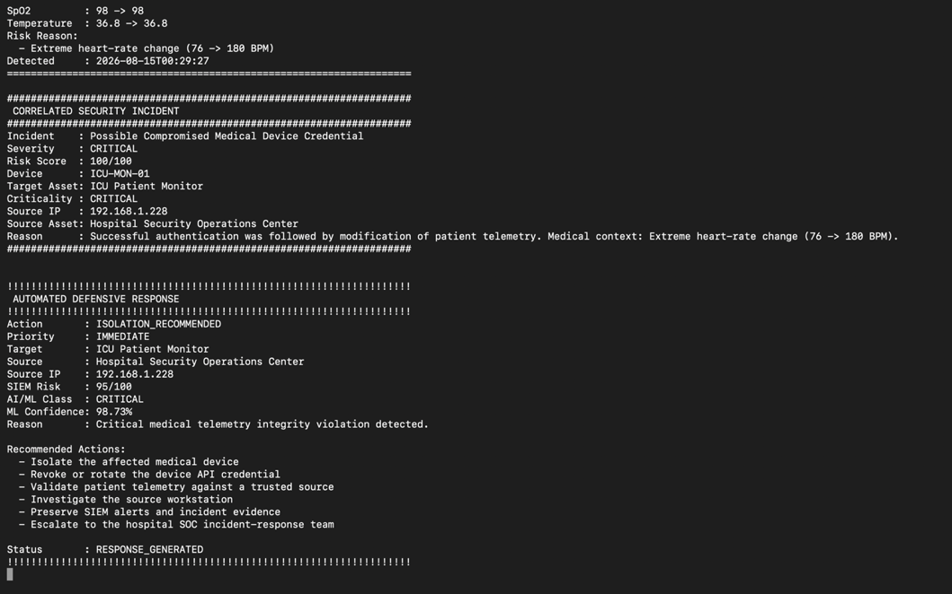
Figure 6. Detection of authenticated telemetry manipulation.

4.5 Correlation and Automated Response
The final implementation correlates related security activity and generates risk-based defensive recommendations.
Security Activity | System Response
Network reconnaissance | ENHANCED_MONITORING
Unauthorized telemetry change | ACCESS_RESTRICTION_RECOMMENDED
Critical authenticated telemetry change | ISOLATION_RECOMMENDED
Repeated authentication failures | Possible Credential Attack
Alerts, correlated incidents and responses are stored in JSONL files, providing persistent evidence for investigation and reporting. Final validation confirmed that the medical IoT monitor, legacy-server monitoring, SIEM, AI/ML analyzer, correlation engine and automated-response components were operational.

5. Ethical & Legal Considerations
All security testing was conducted within an authorized simulated hospital laboratory using Kali Linux, Metasploitable2 and a simulated medical IoT patient monitor. No testing was performed against real healthcare systems or patient devices.
The project followed ethical hacking principles by limiting reconnaissance and access testing to systems specifically created for the project. Patient telemetry was synthetic and contained no real patient information.
The solution also considers security and privacy principles associated with NIST, ISO/IEC 27001 and privacy regulations such as GDPR, including access control, continuous monitoring, incident detection and maintaining auditable security records.
For safety-critical medical systems, the automated-response engine provides actions such as ISOLATION_RECOMMENDED rather than automatically disconnecting a device. This maintains human oversight and reduces the risk of a cybersecurity control disrupting essential healthcare operations.
Overall, the project demonstrates that cybersecurity testing in healthcare must balance security, privacy, authorization and patient safety.

6. Results & Future Improvements
The implemented solution successfully demonstrated monitoring and protection across both the medical IoT patient monitor and legacy hospital server. Testing generated SIEM alerts for network reconnaissance, authentication failures, unauthorized telemetry modification and authenticated telemetry manipulation. Related events were correlated into incidents, while the automated-response engine generated defensive recommendations according to risk.
The project demonstrated the following key outcomes:
- Real-time monitoring of hospital security events.
- Detection of reconnaissance against the legacy server.
- Detection of unauthorized and authenticated telemetry manipulation.
- Medical-aware dynamic risk scoring.
- AI/ML-assisted security classification.
- Event correlation and automated response.
- Persistent alerts, incidents and response records.
The main limitation is that the environment is a small simulated hospital network rather than a production healthcare infrastructure. Future development could expand monitoring to additional medical IoT devices and hospital servers, improve the AI/ML model using larger real-world security datasets, introduce network segmentation and Zero Trust access controls, and integrate a graphical SOC dashboard.
The solution could also be scaled toward an enterprise SIEM architecture with centralized threat intelligence, continuous model retraining and controlled automated containment.
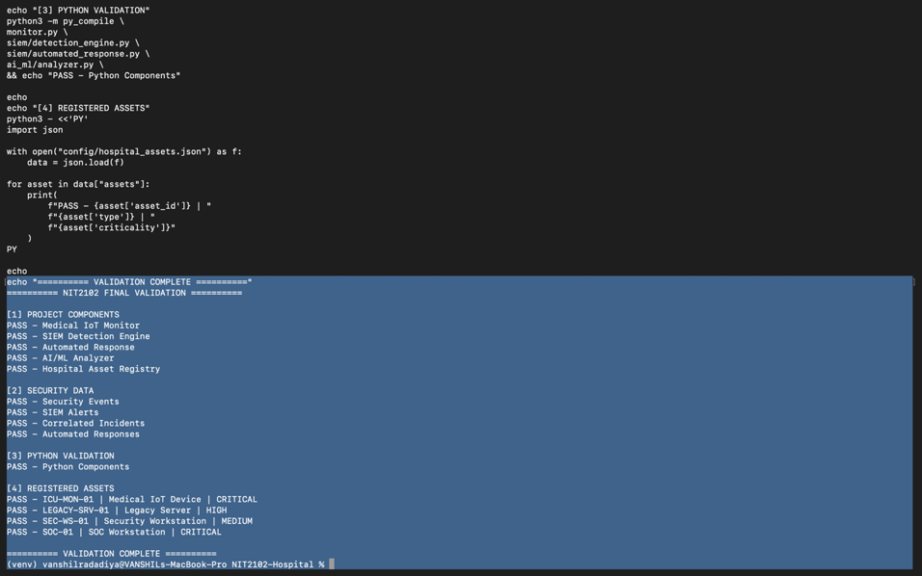
Figure 7. Final validation of the implemented hospital security solution.

7. References
International Organization for Standardization. (2022). ISO/IEC 27001:2022 Information security management systems.
MITRE. (n.d.). MITRE ATT&CK framework.
Nmap Project. (n.d.). Nmap network scanning documentation.
Rapid7. (n.d.). Metasploitable 2 documentation.
U.S. Food and Drug Administration. (2026). Cybersecurity in medical devices.

